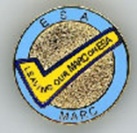

Join us for the
Midwest Area Regional Council
2020 Virtual Leadership Conference
Before you submit your registration, please make a note to remind yourself to go to the MARC Website and read (and print for reference) the following:
- Proposed Budget
- Treasurer’s Report
- Proposed By-Law changes
- Proposed Standing Rule changes

Also, make sure you check out the Mysterious and Remarkable Container flyer and submit your donation to win this awesome box full of wonderful gifts. I happen to know that part of the mystery contents are gift cards for some great stuff.

Name: State:
Are you a current state president? State MARC Rep?

Please email your registration to Kim Poling, MARC Recording Secretary at: a.kimmi.p57@gmail.com by October 2, 2020.

There are no registration fees this year since we will be having a virtual conference. Instructions for accessing the meeting will be provided soon!

